Income Collection for Activities
Cash collection

Cheques collection

- Two members of the Association are assigned to handle cash receipts, one is responsible for collecting cash and the other one is responsible for updating Cash/Cheques Collection register (“register”) (Appendix 1),
- At the end of each day, the responsible persons should perform physical count of cash received and reconcile with the register. Both should sign on the register after reconciliation,
- Any discrepancies must be investigated, rectified and recorded,
- Deposit total cash received on the same day, otherwise, keep the cash in a safety place and then deposit it on the following day.

- Two members of the Association are assigned to handle cheques collection process, one should collect cheques and the other one update the register,
- One responsible person should ensure correct information including amount and date are stated on the cheques which must be ‘crossed’ and made payable to ‘The Education University of Hong Kong’,
- At the end of each day, the responsible persons should count the cheques received, reconcile them with the register and sign the register after all discrepancies have been rectified,
- Deposit the cheques promptly in University’s account with Bank of East Asia.

Expenditure for Activities
The Association has to pass the register and original bank deposit slip to its affiliated Department (“Department”) promptly after the activity.

Deposit cash in University’s account with Bank of East Asia, account no.:
015-195-25-00002-0 and keep the bank deposit slip as supporting.

After checking with the register to the bank deposit slip, the Department should submit the documents with income memo and charging code to FO within one month after the activity.

Single purchase of goods and services value >$5,000

Yes
No
Subject to approval by the Department, the Association can either settle payment through the Department by:
- submission of activity income and expenditure report (“report”) on completion of activity with expenditure supporting for lump-sum claim of expenditure reimbursement, or
- preparation of payment form (Appendix 4) to settle the expenditure on demand.

The Association has to prepare Purchase Requisition form (“PR”) (Appendix 2) and forward it to the Department for approval and further action with reference to next flow chart on ‘Purchase of Goods and Services’.

Department has to sign the Good Received Notes (GRN) (Appendix 3) upon goods received and submitted the GRN to Business Service Section of the FO for process.

FO makes payment with reference to approved GRN.
(Remarks: For case of incomplete documentation, the Association has to provide justification(s) for consideration by the Department and then be submitted to FO for arranging payment if justification is accepted.)

FO makes payment with reference to properly approved and supported report from the Department.

Purchase of Goods and Services

With assistance from the Department, the Association has to prepare payment claims regarding Single Purchase Value Quotations as follows:
Single purchase value | Action
≦ $5,000 | settle direct purchase by payment form
＞$5,000 | has to submit PR to Business Service Section of FO**

** Notes to PR issuance
- allow reasonable time to process PR,
- provide functional specifications in general terms,
- provide an estimated amount for the purchase in the PR,
- don’t confirm order for goods/services before proper purchasing approval is obtained,
- don’t split purchases: by dividing purchases into installments or by reducing the usual duration of contracts,
- properly complete the fields in PR.

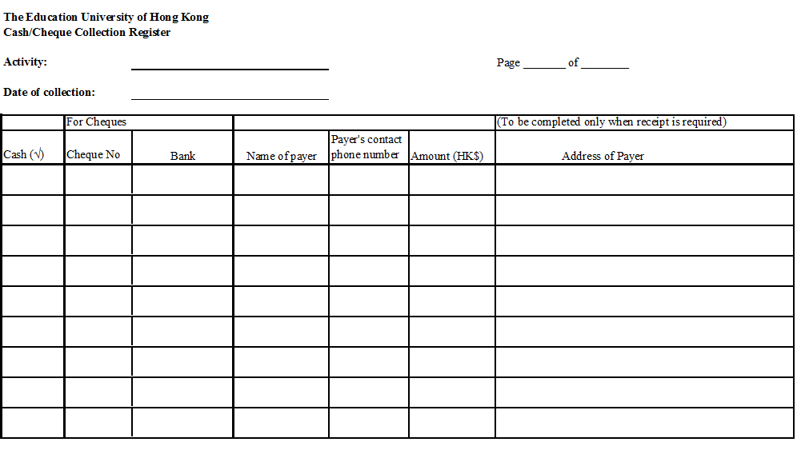
(Cash/Cheques Collection register P.1)

Appendix 1
(Cash/Cheques Collection register P.1)

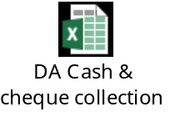

Appendix 1
(Cash/Cheques Collection register P.2)

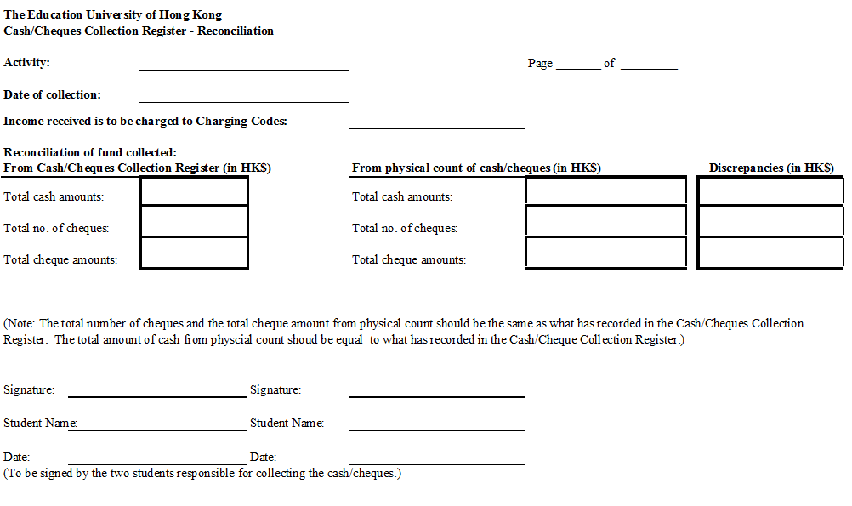
(Cash/Cheques Collection register P.2)

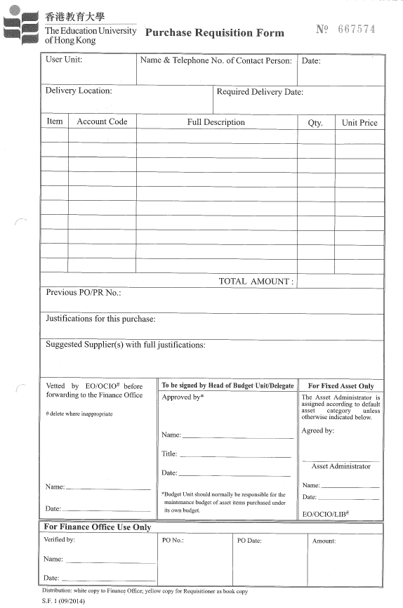
Appendix 2
Purchase Requisition form
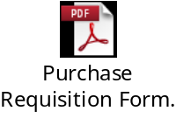

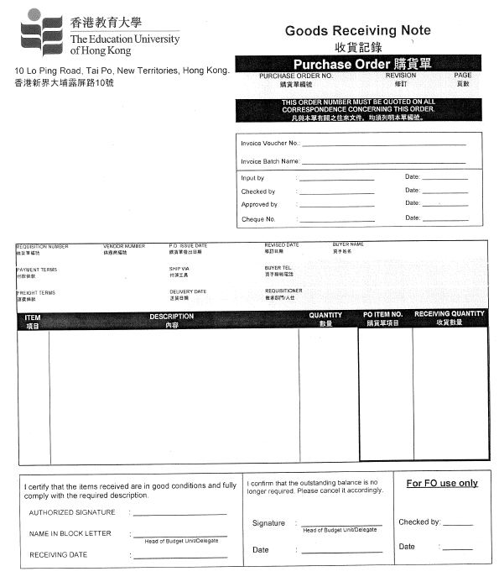
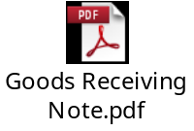
Appendix 3
Good Received Notes
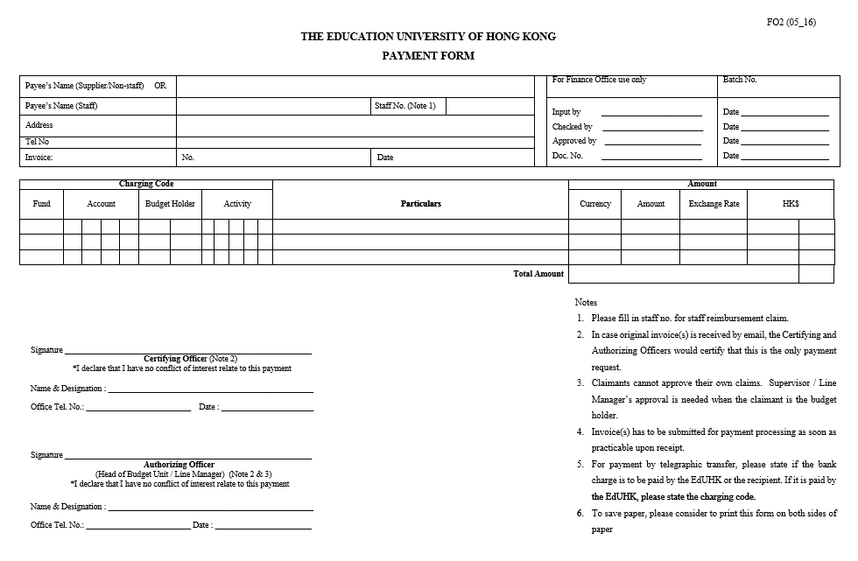
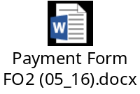
Appendix 4
Payment Form

